# Optimizing Pipeline Costs: Evaluating Corrosion Allowance and Inner FBE Coating for Water Transport Systems

**Ignacio Mella**Victaulic, Chile

## Objective

## This study aims to evaluate the cost-effectiveness of FBE coatings compared to bare steel pipelines, focusing on both capital and operational expenditures.

## Introduction

When comparing a water pipeline constructed with B31.4 steel and a corrosion allowance to one protected with a fusion-bonded epoxy (FBE) coating, the corrosion allowance typically necessitates a significantly thicker pipe wall. This is because an FBE coating serves as a highly effective barrier against corrosion, potentially reducing or even eliminating the need for a substantial corrosion allowance.

Conversely, the smaller internal diameter of a pipe designed with a corrosion allowance, coupled with the increased surface roughness of bare steel compared to an FBE-coated pipe, leads to higher pump power consumption. Additionally, it requires the injection of corrosion inhibitors and other chemicals into the fluid to mitigate corrosion.

As a result, when performing a cost comparison between corrosion allowance and an FBE-coated pipeline, it is essential to account for both CAPEX (Capital Expenditures) and OPEX (Operational Expenditures).

## Case Study Parameters

To quantify this comparison, we analyze an arbitrary case which transports water:

|  |  |
| --- | --- |
| Total pipeline length: | 70,000 km |
| Pipeline Outside diameter: | 28 inches |
| Design flow rate: | **Error! Not a valid link.**L/s |
| Service Life: | **Error! Not a valid link.**years |
| Pipe segment length: | **Error! Not a valid link.** m |
| Steel of pipe: | API 5L X70 |
| Static Head (Elevation change): | **Error! Not a valid link.** m |
| Fluid: | Industrial water |
| Water density: | **Error! Not a valid link.** kg/m³ |
| Dynamic Viscosity of water: | 1.3 cP |
| Kinematic viscosity of water: | **Error! Not a valid link.** m²/s |
| Corrosion rate (FBE coated pipe analysis): | **Error! Not a valid link.** mm/yr |
| Wall thickness (No corrosion): | **Error! Not a valid link.** mm |
| Roughness factor FBE coated pipe year 1: | **Error! Not a valid link.** mm |
| Roughness factor FBE coated pipe year 25: | **Error! Not a valid link.** mm |
| Roughness factor FBE coated pipe year 1: | **Error! Not a valid link.** mm |
| Roughness factor FBE coated pipe year 25: | 0.02**Error! Not a valid link.** mm |
| Electrical energy cost: | **Error! Not a valid link.** $/kWh |

Table . Arbitrary Pipeline Project Data

## Capital Expenditures

### CAPEX · Cost of Steel · Bare Pipe

Let’s calculate total wall thickness which includes the corrosion allowance will be:

$$Wall thickness year 1= t_{1}=9.53 mm+0.2 \text{mm/year}×25 \text{years} = 14.53 mm$$

This will give the pipe an insider diameter of:

$$D_{i}=D_{o}-2⋅t_{1}$$

$$D_{i}=711.2 \text{mm}-2⋅14.53 \text{mm = 682.14 mm}$$

This will help us calculate the weight per meter for the pipe according using the formula for the volume of the material in the pipe and the density of steel for an API 5L X70 pipe:

$$W_{Bare}=A ⋅ ρ= π⋅\frac{\left(D_{o}^{2}-D_{i}^{2}\right)}{4}⋅ρ$$

$$W_{Bare}≈249.6 \text{kg}\text{/}\text{m}$$

Where:

• W: Weight per meter (kg/m).

• A: cross-sectional area (${\text{m}}^{2}$)

• $D_{o}$: Outside diameter (711.2 mm).

• $D_{i}$: Inside diameter (682.14 mm).

• $ρ$: Density of steel ($7850 {\text{kg}\text{/}\text{m}}^{3}$).

Since the pipeline is 70 km long, the total steel weight for the FBE coated pipeline is:

$$W_{\text{total}}=249.6 \text{kg}\text{/}\text{m}⋅70,000 \text{m = }\text{17,475 tonne}$$

### CAPEX · Cost of Steel · FBE coated

For the FBE case, we can also calculate the total weight using the same formula:

But this time, the inside diameter is different when considering 9.53 mm of wall thickness:

$$W_{\text{FBE}}=π⋅\frac{\left({0.7112}^{2}-{(711.2 -2⋅9.53)}^{2}\right)}{4}⋅7850⋅70,000=11,544 \text{tonne}$$

Now, since the primary material used for manufacturing API 5L steel pipes is steel coil we believe that the hot-rolled steel coil (HRC) price is a good reference when estimating the base cost of high-grade API 5L pipes, such as X65 or X70. The raw HRC price typically accounts for 50% of the total X70 Grade API 5L pipe cost.

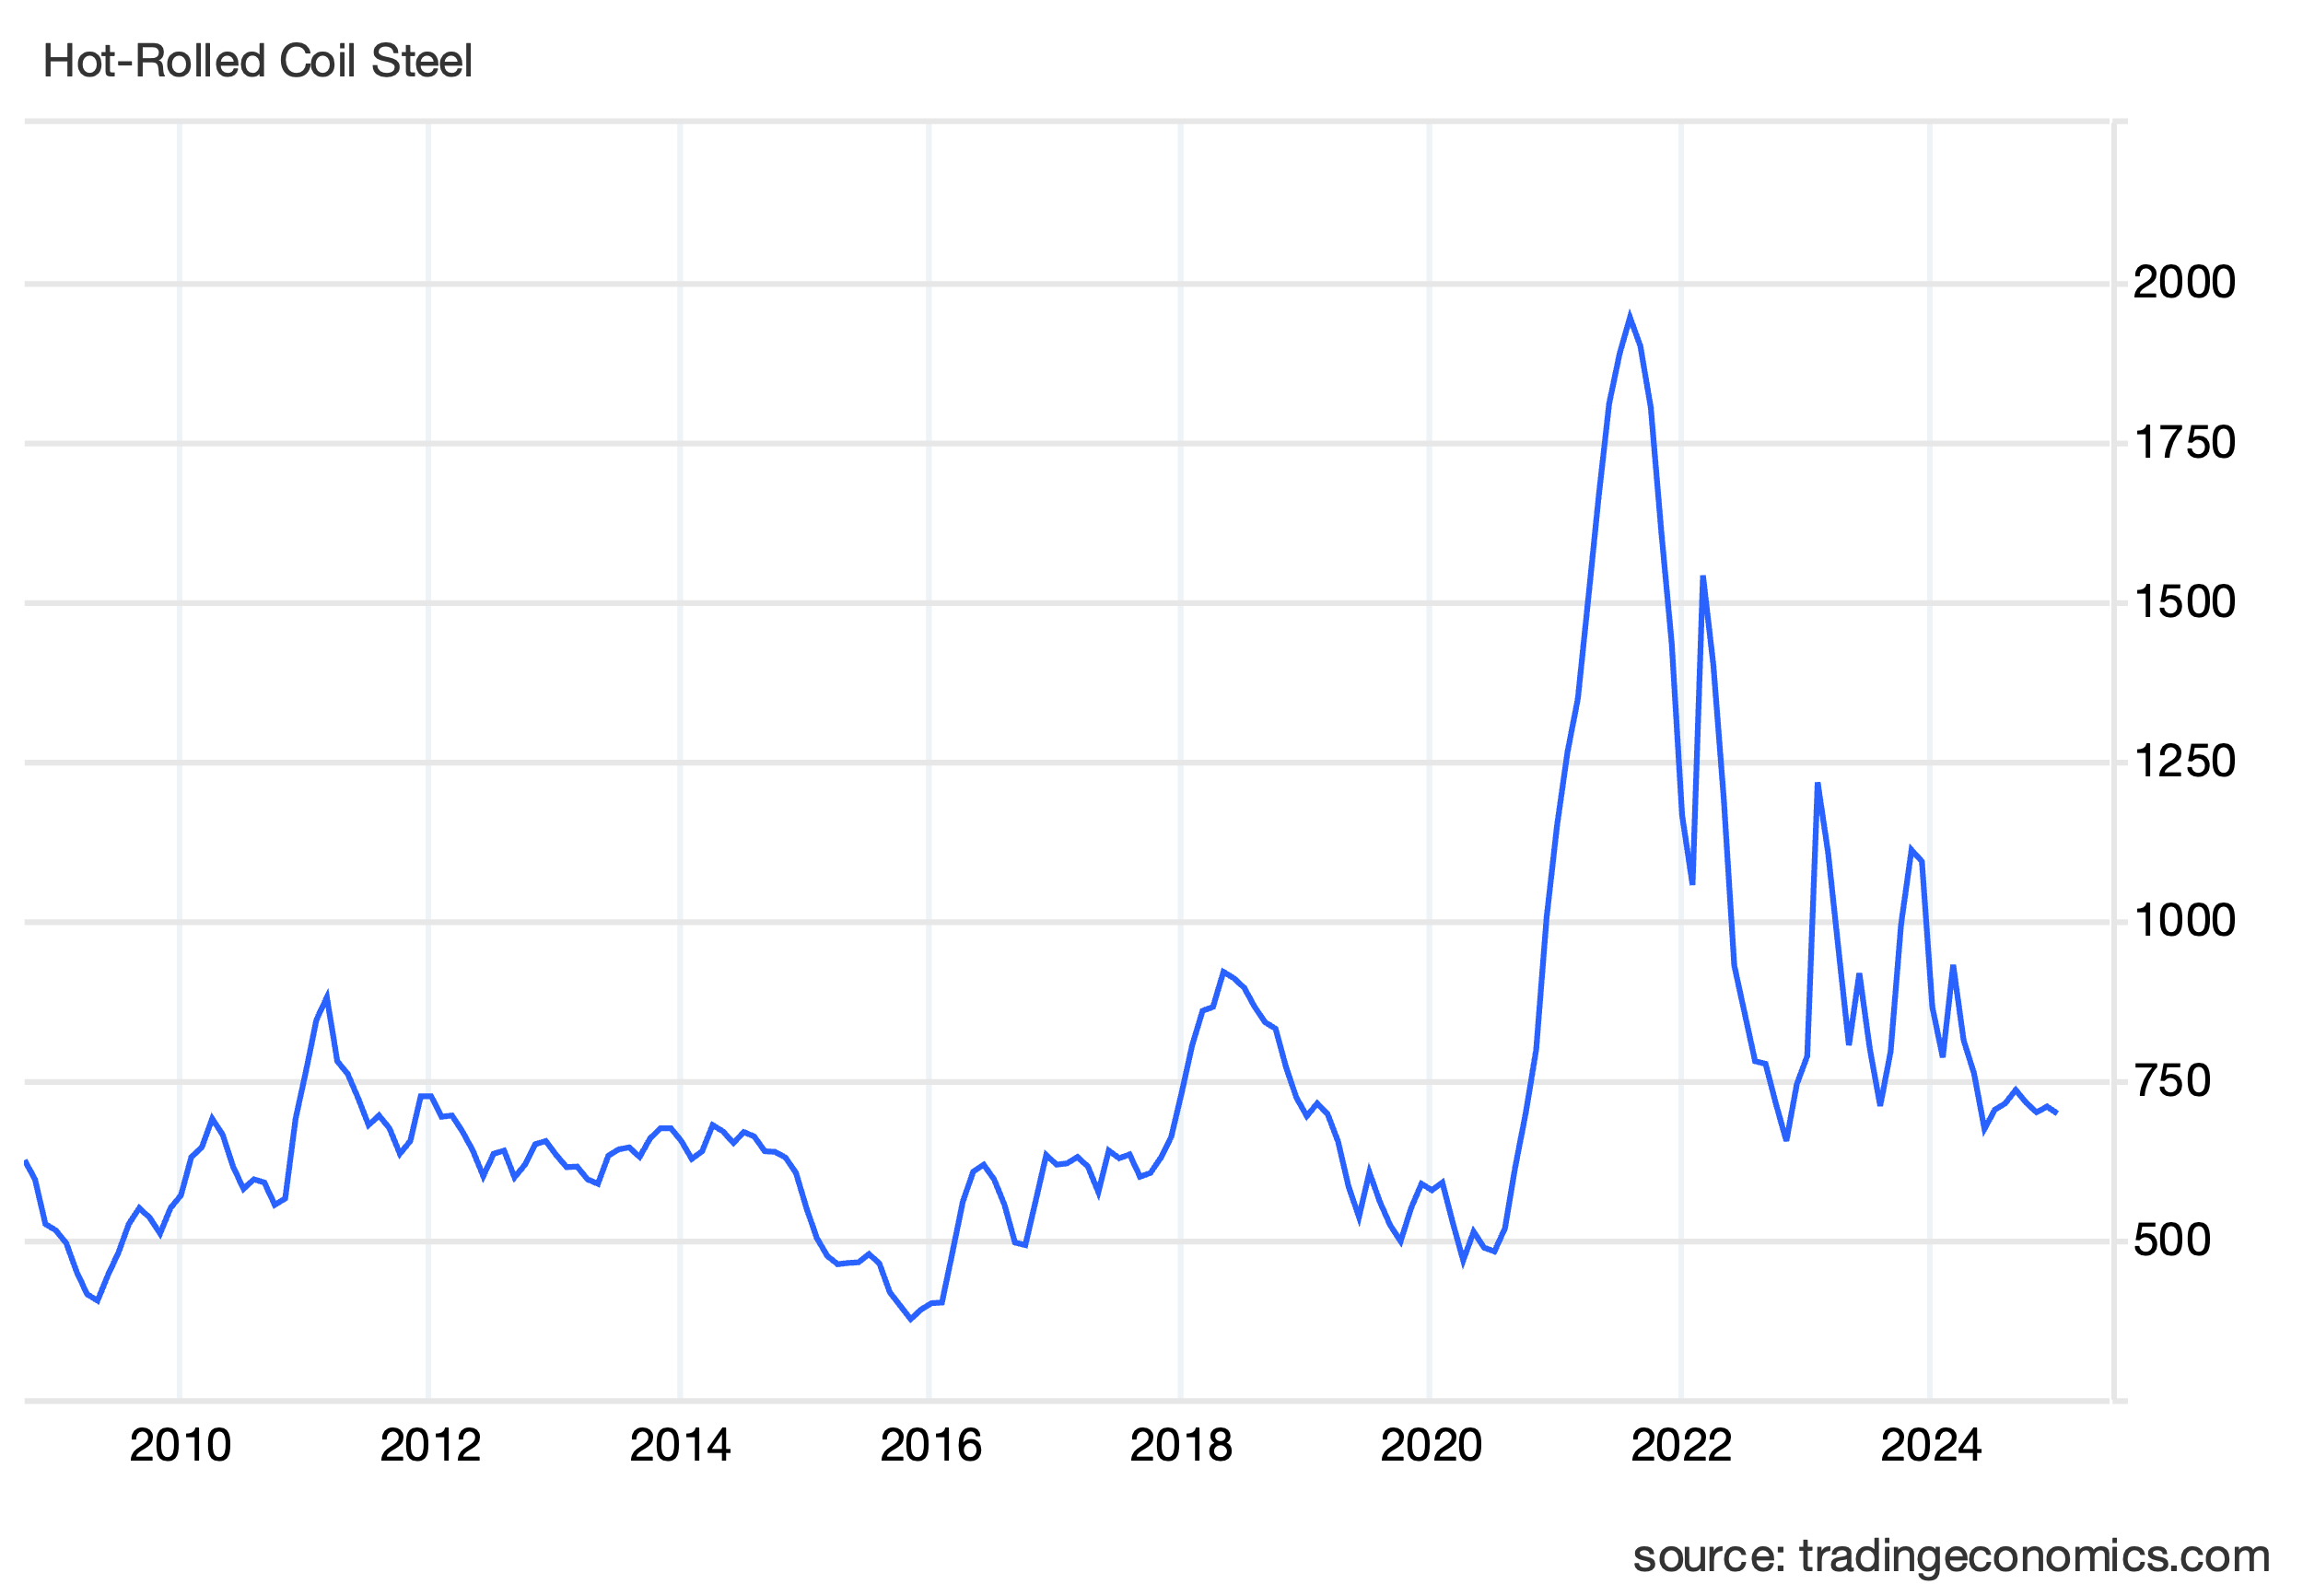Chart 1 China Hot-Rolled Coil Steel (USD/T) price

Now let’s calculate the price of steel for both projects assuming a base price of raw steel.

$P_{\text{raw}}$ = 750 USD per tonne

$$P_{\text{manuf}}=P_{\text{raw}}⋅\left(1+\text{Manufacturing Premium}\right)$$

Where:

• $P_{\text{manuf}}$: Price of manufactured steel pipe. ExWork.

• $P_{\text{raw}}$: Base price of raw steel (**$ 750/tonne**).

• Manufacturing Premium (**50%**): It includes manufacturing additional processes like:

* Rolling and forming the steel plates (15%);
* Heat treatment (7%);
* Welding (12%);
* Quality assurance (4%), and
* Additional cost for stricter chemical composition for X70 (12%).

$$P_{\text{manuf}}=750⋅\left(1+0.50\right)=\text{\$ 1125}\text{/}\text{tonne}$$

This pipe will be transported to Los Andes, Chile from Wuxi, China, and:

$$\text{Transport Cost per Tonne}=\text{Inland (China)}+\text{Ocean Freight}+\text{Inland (Chile)}$$

We will assume:

$\text{Transport Cost per Tonne}=\text{15/tonne}+\text{120/tonne}+\text{35/tonne}$ = $\$\text{ 170}\text{/}\text{tonne}$

Then, the price per tonne for a pipe placed in Chile, including transportation costs, would be:

1125 USD/tonne + 170 USD/tonne = $**1295/tonne**

With this number, we have all we need to calculate the total cost of steel for our two cases.

Bare Pipe case: $\text{17,475 tonne x 1,295 USD/tonne = \$22,629,766}$  
FBE Coated Pipe case: $\text{11,544 tonne x 1,295 USD/tonne = \$ 14,949,034}$

### CAPEX · Cost of Dosing Plant

On the Bare Pipe case, a Dosing Plant is needed to store, handle, and dose chemicals into the water. This plant includes tanks, pumps, pipelines, metering equipment, and control systems for precise chemical injection. It operates continuously to ensure the correct chemical concentrations are maintained in the pipeline.

Will assume that approximate upfront investment required to construct and commission the dosing plant is $ 6 per m³/day. Then, for a 400 L/s pipeline:

$$\text{Total Cost}=34,560 \text{m³}\text{/}\text{day}×6 \text{\$}\text{/}\text{m³}\text{/}\text{day = }\text{\$ 207,360}$$

### CAPEX · Cost of FBE coating

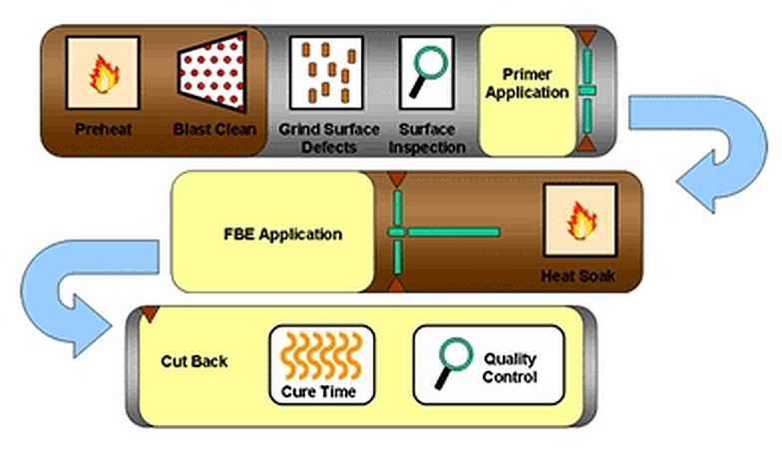Fusion-Bonded Epoxy inner coating involves a series of well-coordinated processes that incur upfront capital expenditure. These costs include acquiring high-grade epoxy powder, setting up or accessing specialized coating facilities, and managing labor-intensive applications such as surface preparation, powder application, and curing.

Schematic . Typical FBE coating application process at coating facility

Additional expenses arise from transportation to coating facilities, rigorous quality assurance, and environmental compliance.

The estimated breakdown cost per surface area attributable to FBE coating is as follows:

|  |  |
| --- | --- |
| Cost Component | Cost per m² |
| FBE Powder Material | $4.20 |
| Application Costs | $3.00 |
| Transportation Costs | $1.80 |
| Quality Control & Testing | $1.20 |
| Miscellaneous (Overheads) | $1.80 |
| Total | $12.00 |

Table . Estimated FBE coating costs breakdown.

To calculate the total FBE CAPEX we simply need to multiply this surface cost, by the total inner pipe surface. The formula for the surface area of a cylinder is:

$$\text{Inner Surface Area (m²)}=π×Inner \text{Diameter (m)}×\text{Length (m)}$$

$$\text{Outer Diameter}=28 \text{inches}=28×0.0254=0.7112 \text{m}$$

Subtracting the wall thickness (9.53 mm = 0.00953 m):

$$\text{Inner Diameter}=0.7112-\left(2×0.00953\right)=0.69214 \text{m}$$

$$\text{Surface Area per meter}=π×0.69214≈2.175 \text{m²}\text{/}\text{m}$$

$$\text{Total Surface Area}=2.175 \text{m²}\text{/}\text{m}×70,000 \text{m}≈152,210 \text{m²}$$

Hence, the total FBE CAPEX for a 300-micron coating thickness is:

$$\text{Total CAPEX}=12 \text{USD}\text{/}\text{m²}×152,210 \text{m²}= \$1,826,514 \text{USD}$$

### CAPEX · Internal Robotic Field FBE Coating

On site, the pipes are welded together sequentially, but the heat generated during welding will burn and destroy the manufacturer's inner FBE coating. To address this, a coating cutback is employed, leaving a small section (typically between 50–100 mm) of the pipe’s interior uncoated near the ends to facilitate welding. Typically, most of the internal field joint coating is done using self-contained robot that travel inside the pipe.

Schematic . Self-contained robot for internal Liquid Epoxy coating

However, coating the inner coating after welding is challenging and rarely achieves the same quality as the original factory-applied coating. These areas are considered weak points in the  
pipeline, as they are more prone to premature corrosion.

Ferrous oxide

Photo . Factory-applied Fusion Bonded Epoxy

Photo . Field applied Liquid Epoxy next to weld inner seam

Contaminated reverse dolly

Although both direct and indirect costs must be accounted for, this study will only quantify direct costs associated to expenses related to coating the inner welds. Indirect costs, on the other hand, arise from production losses or downtime during repairs, shrinkage, and other factors, such as environmental damages. Studies on losses due to pipeline damage indicate that of all the factors or causes underlying failures, approximately 55% are due to internal corrosion (National Association of Corrosion Engineers Report, NACE – 2012).

|  |  |
| --- | --- |
| Cost Component | Cost per Joint |
| Mobilization of Crew & Equipment | $27 |
| Demobilization of Crew & Equipment | $16 |
| Personnel & Robotic Equipment | $627 |
| Pre-blasting Personnel & Equipment | $186 |
| Internal Coating Application | $225 |
| Pipe-End Pre-blasting | $60 |
| Total Cost per Joint | $1,150 |

Table . Cost breakdown per joint of the Robotic Internal Field Joint Coating Service

The total FBE direct costs related to internally coating the pipeline welds is:

$$\text{Total Joints}=\frac{\text{Pipeline Length}}{\text{Joint Length}}=\frac{70,000}{12}≈5,833 joints$$

$$\text{Total Cost}=5,833 joints×1,150 \$/joint=\$ 6,707,950 \text{USD}$$

## Operational Expenditures

### OPEX · Corrosion inhibitors and other chemicals injection

For the Bare Pipe case, there are expenses for adding corrosion inhibitors and other chemicals to adjust water pH or reduce the impact of dissolved gases (e.g., oxygen, carbon dioxide) that accelerate corrosion. For this project, we will assume:

|  |  |
| --- | --- |
| Cost item | Monthly cost per L/s |
| Corrosion inhibitor through passivation | $70 |
| Deoxygenation Agents | $50 |
| Biocide | $9 |
| pH Adjusters | $3 |
| Energy Cost | $5 |
| Application and QA service | $18 |
| Total | $155 |

Table . Monthly cost breakdown for corrosion inhibitors and other chemicals

Thus, the yearly cost for a 400 L/s would be:

$$Yearly cost=\text{Flow rate (L}\text{/}\text{s)}×\text{Monthly cost per L}\text{/}\text{s}×\text{Months in a year}$$

$$Yearly cost=400 \text{L}\text{/}\text{s}×155 \text{\$}\text{/}\text{L}\text{/}\text{s}\text{/}\text{month}×12 months=\$ 744,000$$

We will assume there is no similar OPEX associated to the FBE Coated case.

### OPEX · Bare Pipe case · Inspections

Regular inspections and maintenance costs associated to monitor wall thickness degradation over time. These inspections typically use non-destructive testing methods (e.g., ultrasonic or magnetic flux leakage) to assess remaining wall thickness and detect pitting or localized corrosion. For both cases, we will assume MFL (Magnetic Flux Leakage) Testing

The annual OPEX for MFL Testing can be estimated using the formula:

$$\text{Annual OPEX (FBE coated pipe)}=\text{Pipeline Length (km)}×MFL Testing \text{Cost per km}$$

If we assume $2,000 per km per year for MFL testing:

$$\text{Annual OPEX (FBE coated pipe)}=70 \text{km}×2,000 \text{\$}\text{/}\text{km = }\text{140,000 \$/year}$$

### OPEX · FBE Inner Coating Case · Inspections

Contrary to the FBE coated pipe, MFL may not be Ideal for FBE Inner coated pipelines because corrosion is significantly mitigated, and metal loss is unlikely to progress rapidly. Therefore, MFL might not provide actionable insights if the coating is intact, so we will assume that High-Resolution Ultrasonic Testing (UT) is the preferred choice. This inspection service is 20% less expensive than MFL and usually require less frequent inspections or inspections that focus on coating. A typical UT testing strategy for FBE coated pipe would be:

• Perform baseline UT testing during commissioning to establish initial wall thickness and coating condition.

• Conduct the next UT inspection within 3–5 years, assuming no significant issues are detected in the baseline data.

• Routine UT testing every 5–10 years

Assuming a 65% reduction in OPEX compared to uncoated pipes, we estimate:

$$\text{Annual OPEX (coated pipe)}=140,000 \text{\$}\text{/}\text{year}×0.35=49,000 \text{\$}\text{/}\text{year}$$

## OPEX · Energy Costs · FBE Inner Coating case

Two widely used methods to calculate pump energy consumption in pipelines are the Darcy-Weisbach equation (using a roughness factor) and the Hazen-Williams equation (using an empirical roughness coefficient).

In this paper, we believe that the Darcy-Weisbach equation is the better choice for calculating energy consumption over 25 years in a FBE coated pipe with a changing inner diameter due to erosion. This method provides a more accurate representation of friction losses because it explicitly accounts for the roughness factor (*k*) and its relationship with the inner diameter (ID) and Reynolds number. Since the ID and surface roughness will change over time as the pipe erodes, the Darcy-Weisbach equation provides accurate calculations by accounting for changing pipe roughness and diameter over time of head loss and energy requirements.

In contrast, the Hazen-Williams equation uses an empirical roughness coefficient (C) that assumes a fixed pipe condition, making it less suitable for long-term analysis where pipe characteristics evolve.

Next, we calculate the energy consumption for the first year.

$$\text{Pipe Cross Sectional Area}=A=π⋅{\left(\frac{D}{2}\right)}^{2}=π⋅{\left(\frac{0.6921}{2}\right)}^{2}=0.3762 {\text{m}}^{2}$$

$$Flow Velocity=v=\frac{Q}{A}=1.063 \text{m}\text{/}\text{s}$$

To derive the Friction Factor (*f*) for the first year using the roughness factor (*k*) in the Darcy-Weisbach equation, we will calculate *f* explicitly using the Colebrook-White equation:

$$\frac{1}{\sqrt{f}}=-2\log_{10}\left(\frac{k}{3.7D}+\frac{2.51}{Re⋅\sqrt{f}}\right)$$

Where:

• *f* : Friction factor (what we solve for)

• $k$: Roughness factor for FBE-coated pipe

• $D$: Inner diameter

• $v=$ Flow velocity

• *Re* = $\frac{vD}{ν}$: Reynolds number

We now solve for *f* iteratively using the Newton-Raphson method until convergence:

• Reynolds Number ( *Re* ): 668,934

• Friction Factor ( *f* ): 0.0126163

Using the Darcy-Weisbach equation we can calculate the Head Loss:

$$h_{l} = f⋅\frac{L}{D}⋅\frac{v^{2}}{2g} = 0.0126163 ⋅\frac{70,000}{0.69214}⋅\frac{{\left(1.061\right)}^{2}}{2⋅9.81} ≈ 73.5 m$$

We can now calculate the Total Pump Power as:

$$P=\frac{ρ⋅g⋅Q⋅\left(h_{l}+h_{StaticHead}\right)}{η}=\frac{1025⋅9.81⋅0.4⋅ (1000+73.5)}{0.82}≈5265.5 kW$$

The formula for calculating the operational expenditure (OPEX) is:

$$\text{OPEX (year 1)}=P⋅T⋅C = 5265.5 kW⋅8410 h⋅0.107 \$/kWh = \$ 4,738,067$$

Where:

• P : Pump power in kilowatts ( $\text{kW}$) = 363.5 kW

• T : Total operating hours in a year ( $\text{h}\text{/}\text{year}$) = 8410 h/year

• C : Electricity cost per kilowatt-hour ( $\text{\$}\text{/}\text{kWh}$) = 0.107 $/kWh

For FBE inner coated pipe, increase in *k* is typically small for well-maintained pipelines. Below, some industry estimates for FBE roughness over 25 years:

• Initial Roughness ( k ): $0.005 \text{mm}-0.03 \text{mm}$

After 25 Years (well-maintained):

• Minor Fouling: $0.03 \text{mm}-0.06 \text{mm}$

• Moderate Fouling/Damage: $0.06 \text{mm}-0.10 \text{mm}$

• Severe Conditions $:>0.1 \text{mm}$, but this is rare.

For this arbitrary project, we will assume a Roughness factor of 0.08 mm by year 25 and a linear degradation.

|  |  |  |  |  |  |  |
| --- | --- | --- | --- | --- | --- | --- |
| Project Year | Pipe inner  diameter | Roughness factor *k* | Friction  Factor *f* | Friction  Head Loss | Pump  Total Power | Electricity OPEX |
| 1 | 0.69214 m | 0.005 mm | 0.0125747 | 73.5 m | 5265.5 kW | 4,738,067 |
| 2 | 0.69214 m | 0.008 mm | 0.0126596 | 73.8 m | 5266.8 kW | 4,739,181 |
| 3 | 0.69214 m | 0.011 mm | 0.0127425 | 74.2 m | 5269.1 kW | 4,741,313 |
| 4 | 0.69214 m | 0.014 mm | 0.0128236 | 74.7 m | 5271.5 kW | 4,743,396 |
| 5 | 0.69214 m | 0.018 mm | 0.0129028 | 75.2 m | 5273.7 kW | 4,745,433 |
| 6 | 0.69214 m | 0.021 mm | 0.0129803 | 75.6 m | 5275.9 kW | 4,747,427 |
| 7 | 0.69214 m | 0.024 mm | 0.0130562 | 76.1 m | 5278.1 kW | 4,749,379 |
| 8 | 0.69214 m | 0.027 mm | 0.0131306 | 76.5 m | 5280.2 kW | 4,751,292 |
| 9 | 0.69214 m | 0.030 mm | 0.0132036 | 76.9 m | 5282.3 kW | 4,753,167 |
| 10 | 0.69214 m | 0.033 mm | 0.0132751 | 77.3 m | 5284.4 kW | 4,755,007 |
| 11 | 0.69214 m | 0.036 mm | 0.0133453 | 77.7 m | 5286.4 kW | 4,756,812 |
| 12 | 0.69214 m | 0.039 mm | 0.0134143 | 78.2 m | 5288.3 kW | 4,758,585 |
| 13 | 0.69214 m | 0.043 mm | 0.0134820 | 78.5 m | 5290.3 kW | 4,760,327 |
| 14 | 0.69214 m | 0.046 mm | 0.0135486 | 78.9 m | 5292.2 kW | 4,762,040 |
| 15 | 0.69214 m | 0.049 mm | 0.0136141 | 79.3 m | 5294.0 kW | 4,763,724 |
| 16 | 0.69214 m | 0.052 mm | 0.0136785 | 79.7 m | 5295.9 kW | 4,765,380 |
| 17 | 0.69214 m | 0.055 mm | 0.0137419 | 80.1 m | 5297.7 kW | 4,767,010 |
| 18 | 0.69214 m | 0.058 mm | 0.0138043 | 80.4 m | 5299.5 kW | 4,768,615 |
| 19 | 0.69214 m | 0.061 mm | 0.0138658 | 80.8 m | 5301.2 kW | 4,770,196 |
| 20 | 0.69214 m | 0.064 mm | 0.0139263 | 81.1 m | 5303.0 kW | 4,771,753 |
| 21 | 0.69214 m | 0.068 mm | 0.0139860 | 81.5 m | 5304.7 kW | 4,773,287 |
| 22 | 0.69214 m | 0.071 mm | 0.0140449 | 81.8 m | 5306.4 kW | 4,774,800 |
| 23 | 0.69214 m | 0.074 mm | 0.0141029 | 82.2 m | 5308.0 kW | 4,776,292 |
| 24 | 0.69214 m | 0.077 mm | 0.0141601 | 82.5 m | 5309.6 kW | 4,777,764 |
| 25 | 0.69214 m | 0.080 mm | 0.0142166 | 82.8 m | 5311.3 kW | 4,779,216 |

Table . Electricity OPEX for the FBE inner coating case.

As it can be seen from the table above, the impact on electricity expenditure due to moderate fouling/damage on the FBE coating is negligible.

## OPEX · Energy Costs · FBE coated pipe case

### Initial ID Reduction Due to Corrosion Allowance

FBE coated pipe requires a corrosion allowance to account for material loss over the pipeline’s service life (25 years). This results in a smaller initial inner diameter (ID) of 682.54 mm, compared to the FBE-coated pipe’s 692.14 mm.

A smaller ID increases flow velocity, friction losses, and pump power requirements. Also, it directly increases the head loss in the Darcy-Weisbach equation because the frictional term ($\frac{1}{D}$) is inversely proportional to the diameter.

**Roughness Factor for Bare Steel Pipe**

The roughness factor (*k*) for bare steel is much higher than FBE with an initial *k* of 0.03 mm (bare) vs. 0.005 mm (FBE). Over time: Bare steel roughness increases due to fouling, scaling, and surface degradation, probably reaching 0.1 mm or more after 25 years.

Higher *k* values increase the friction factor (*f* ) in the Darcy-Weisbach equation, leading to greater head loss and pump power requirements.

For reader clarity, we have moved the FBE coated pipe calculations to **Appendix A – FBE coated pipe Energy Expenditure Calculations**.

|  |  |  |  |  |  |  |  |
| --- | --- | --- | --- | --- | --- | --- | --- |
| Year | Inner diameter | Flow vel | Roughness factor | Friction Factor | Friction Head Loss | Pump Total Power | OPEX |
| 1 | 0.68254 m | 1.0932 m/s | 0.030 mm | 0.0131784 | 82.3 m | 5308.8 kW | 4,777,031 |
| 2 | 0.68294 m | 1.0920 m/s | 0.028 mm | 0.0131520 | 81.9 m | 5306.8 kW | 4,775,241 |
| 3 | 0.68334 m | 1.0907 m/s | 0.032 mm | 0.0132260 | 82.1 m | 5307.9 kW | 4,776,215 |
| 4 | 0.68374 m | 1.0894 m/s | 0.035 mm | 0.0132986 | 82.4 m | 5309.0 kW | 4,777,138 |
| 5 | 0.68414 m | 1.0881 m/s | 0.038 mm | 0.0133697 | 82.6 m | 5309.9 kW | 4,778,015 |
| 6 | 0.68454 m | 1.0869 m/s | 0.041 mm | 0.0134394 | 82.7 m | 5310.8 kW | 4,778,847 |
| 7 | 0.68494 m | 1.0856 m/s | 0.044 mm | 0.0135079 | 82.9 m | 5311.7 kW | 4,779,636 |
| 8 | 0.68534 m | 1.0843 m/s | 0.047 mm | 0.0135751 | 83.1 m | 5312.6 kW | 4,780,384 |
| 9 | 0.68574 m | 1.0831 m/s | 0.050 mm | 0.0136410 | 83.3 m | 5313.3 kW | 4,781,093 |
| 10 | 0.68614 m | 1.0818 m/s | 0.053 mm | 0.0137059 | 83.4 m | 5314.1 kW | 4,781,765 |
| 11 | 0.68654 m | 1.0805 m/s | 0.057 mm | 0.0137696 | 83.5 m | 5314.8 kW | 4,782,400 |
| 12 | 0.68694 m | 1.0793 m/s | 0.060 mm | 0.0138323 | 83.7 m | 5315.5 kW | 4,783,001 |
| 13 | 0.68734 m | 1.0780 m/s | 0.063 mm | 0.0138939 | 83.8 m | 5316.1 kW | 4,783,569 |
| 14 | 0.68774 m | 1.0768 m/s | 0.066 mm | 0.0139546 | 83.9 m | 5316.7 kW | 4,784,105 |
| 15 | 0.68814 m | 1.0755 m/s | 0.069 mm | 0.0140143 | 84.0 m | 5317.3 kW | 4,784,610 |
| 16 | 0.68854 m | 1.0743 m/s | 0.072 mm | 0.0140731 | 84.2 m | 5317.8 kW | 4,785,086 |
| 17 | 0.68894 m | 1.0730 m/s | 0.075 mm | 0.0141310 | 84.3 m | 5318.3 kW | 4,785,533 |
| 18 | 0.68934 m | 1.0718 m/s | 0.078 mm | 0.0141881 | 84.4 m | 5318.7 kW | 4,785,954 |
| 19 | 0.68974 m | 1.0705 m/s | 0.082 mm | 0.0142444 | 84.4 m | 5319.2 kW | 4,786,347 |
| 20 | 0.69014 m | 1.0693 m/s | 0.085 mm | 0.0142998 | 84.5 m | 5319.6 kW | 4,786,716 |
| 21 | 0.69054 m | 1.0681 m/s | 0.088 mm | 0.0143545 | 84.6 m | 5320.0 kW | 4,787,060 |
| 22 | 0.69094 m | 1.0668 m/s | 0.091 mm | 0.0144085 | 84.7 m | 5320.3 kW | 4,787,380 |
| 23 | 0.69134 m | 1.0656 m/s | 0.094 mm | 0.0144618 | 84.7 m | 5320.7 kW | 4,787,677 |
| 24 | 0.69174 m | 1.0643 m/s | 0.097 mm | 0.0145143 | 84.8 m | 5321.0 kW | 4,787,952 |
| 25 | 0.69214 m | 1.0631 m/s | 0.100 mm | 0.0144937 | 84.4 m | 5319.2 kW | 4,786,341 |

# Appendix A – FBE coated pipe Energy Expenditure Calculations